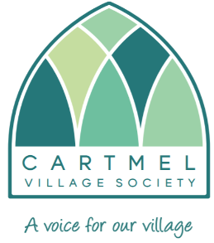
Cartmel Village Society Newsletter: April 2020

From David Crabtree, our Chairman

We find ourselves in the middle of a global pandemic, with the COVID-19 virus having changed our lives enormously since my last newsletter.

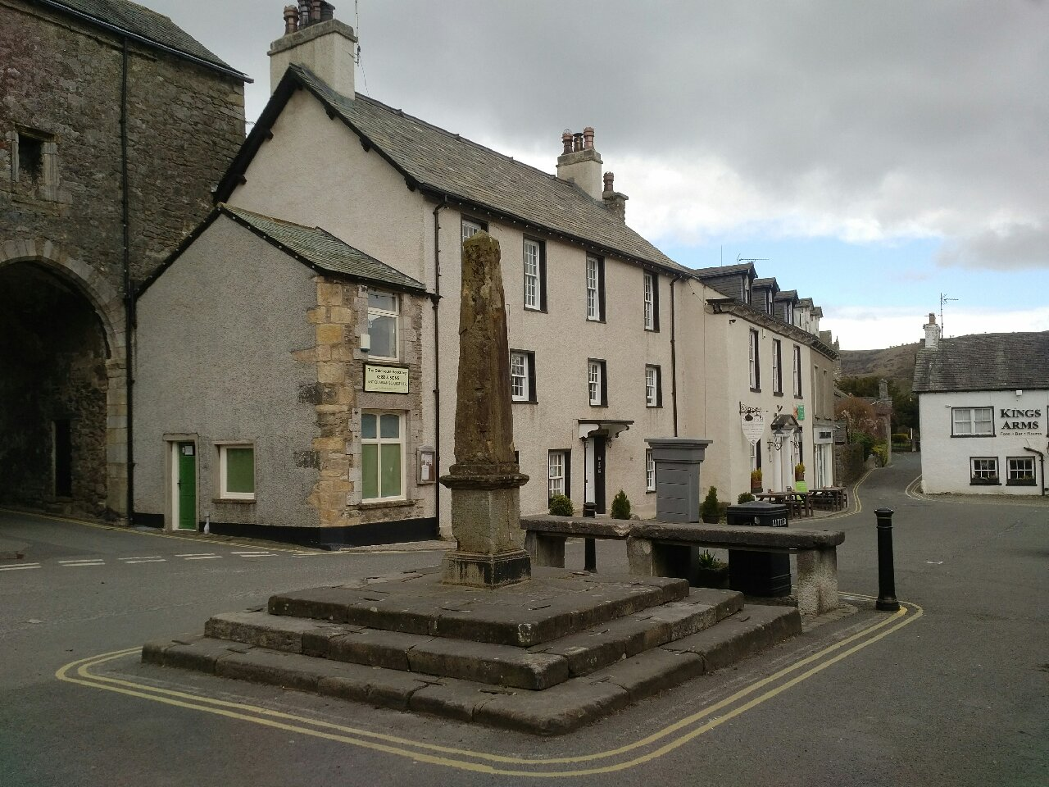
Picture of the deserted Market Square.

The Cartmel Village Society are strongly supporting the CARTNET initiative which is helping our community during this crisis. Ewen Cameron had the foresight to set it up and has worked tirelessly to make it all happen.
Our heartfelt thanks go out to Ewen who commented ‘As the severity of the COVID-19 pandemic and the Government’s measures became apparent, as previous coordinator of the village Neighbourhood Watch I realised that something needed to be done locally to help the village and valley residents. I feel that a lot of neighbourly support would have naturally occurred but the setting up of CARTNET has helped to coordinate the activity and avoid anyone being overlooked. It is vital that anyone who is in need or is vulnerable knows where to turn when they have a problem during this crisis.’
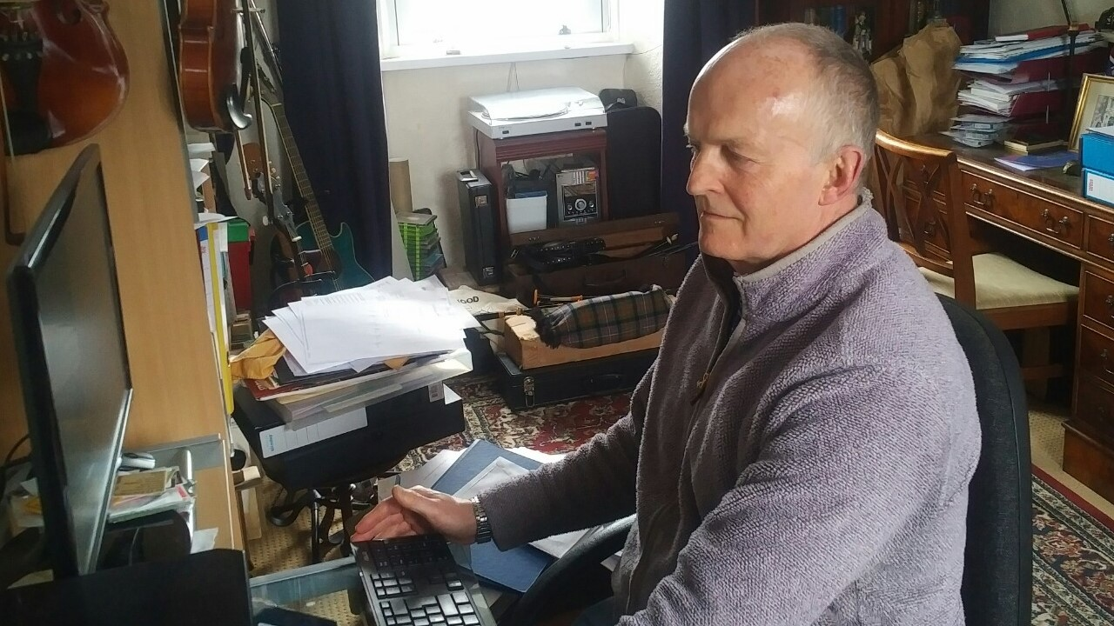
Ewen working at his desk

Via our Societies website, http://www.cartmelvillagesociety.co.uk and Facebook page, we are providing vital focal points for all communications relating to CARTNET.

Please utilise them both, as information is being updated on a regular basis including shopping and delivery lists, local councils’ news, medical advice from the local surgeries and how to offer yourself for volunteer work with CARTNET deliveries and shopping for the vulnerable etc.

An enormous thank you to all the volunteers, who have offered their help to those in need during this difficult time. There have been many examples of the volunteers delivering shopping and picking up medicines.
In addition, we have added a number of the CVS team to the volunteers, who are helping the cause with their various skills.

If you have any information that you feel is particularly relevant to the current situation and that you feel others would benefit from, then please contact craigjohnson1803@gmail.com

On a lighter note the recent crisis has provided an unlikely platform for us to make more people aware of our activities and has set us thinking how we might offer more of a one stop shop of information for both residents, businesses and visitors.

SUPPORT OUR LOCAL FARMERS

In our previous communications, the Cartmel Village Society has attempted to support all
our local residents and businesses by identifying those that will provide a delivery service to people who are isolating at home. Fortunately, many of the local shops are now reporting record levels of business – long may this continue.

But there is also one part of our local community who are experiencing special difficulties at the present time and that is our local farmers who in addition to their normal challenges are seeing large quantities of foreign imports affecting their livelihoods.
Please when you are contacting our local shops regarding meat and other farm produce, ask them to supply local farmed goods and see what we can all do to support our local farmers.

BRIGHTEN YOUR DAY WITH FLOWERS

Cartmel in Bloom each year organises a number of community events to raise funds for their ongoing activities which include litter picking, arranging some of the floral displays in the village and making donations to local good causes, in particular our local schools. One of these events is our annual plant sale held at the Village Hall which in itself raises funds for charities such as Growing Well at Sizergh Farm and our local hospice. In view of the current Covid-19 situation this year's event has been cancelled.

Given the support that we have received from our community, we would like to reciprocate that support by offering each household covered by the CARTNET area a small selection of plants for their enjoyment. Our idea is to bring a little cheer to brighten both your day and hopefully your garden, container or basket.
If you are interested would you please email gillianbates@rocketmail.com or phone Gill on 07901 717056, providing your contact details by 24th April.

Whilst you are at home self-isolating/distancing, when you have a moment could you kindly think how the CVS could financially support a project that will benefit the future of our village and help to conserve our heritage. Please email any suggestions to craigjohnson1803@gmail.com

Finally stay safe, there really is light at the end of the tunnel.

