Cartmel Priory School – May 2021

We hope we are starting to return to some form of normality.
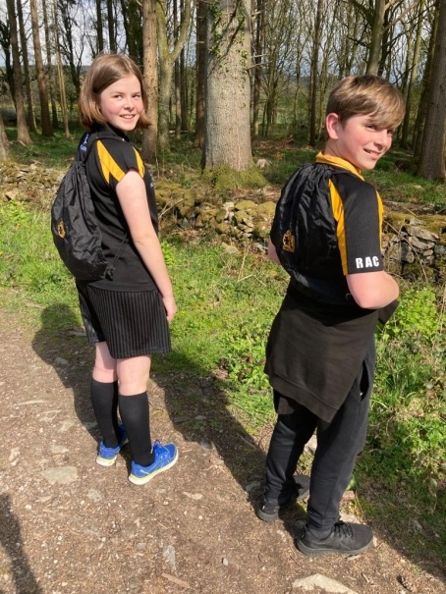
Clubs this half term have included Athletics, Rounders, Fitness and Running Clubs along with additional booster sessions for students. The clubs are still very well attended and the students are enjoying some team sports along with some much needed sunshine. Running Club have taken part in The Great Big School Clean, collecting any rubbish from the environment in back packs as they run. We have continued to raise money for our Rwanda Water Tank appeal by holding a Charity non-uniform day in school.

Our on-site tennis courts are now due for a massive refurbishment and we have just launched a fundraising campaign to find the money required to upgrade the surface and surrounding fences. This is a much used area of the school and much needed resource for the students. We will be focussing a lot of our effort in the coming months to raising funds for this project. Please follow our Facebook page for updates on our progress with this. We would welcome any support as, once refurbished, the courts will be available outside of school hours at specific times for the benefit of the local community.
Finally we would like to showcase one of our students, Alice W. who has done an amazing job as a volunteer co-ordinator and vaccination steward at the vaccination centre in Grange. We are very proud of her! Well done Alice.

